Maisqual Projects/Ant Analysis

1) Does more source lines means there is more effective lines?

SLOC----source lines of code

ELOC----effective lines of code

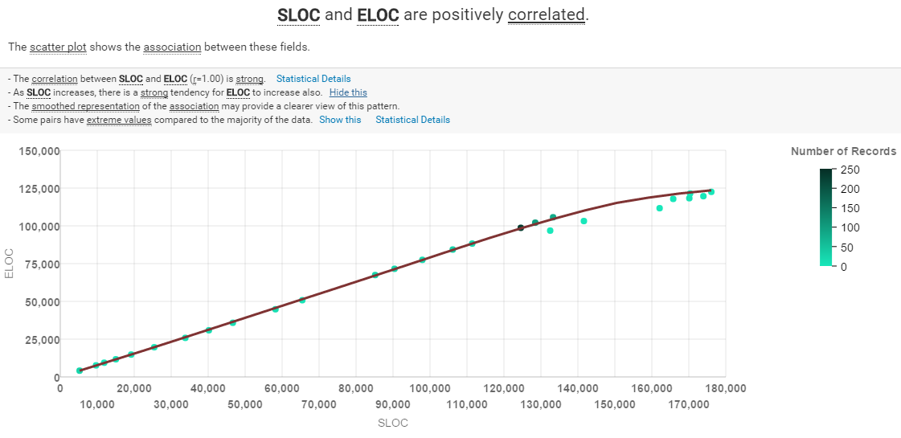

From the regression graph we can see that source lines of code and effective lines of code is positively correlated

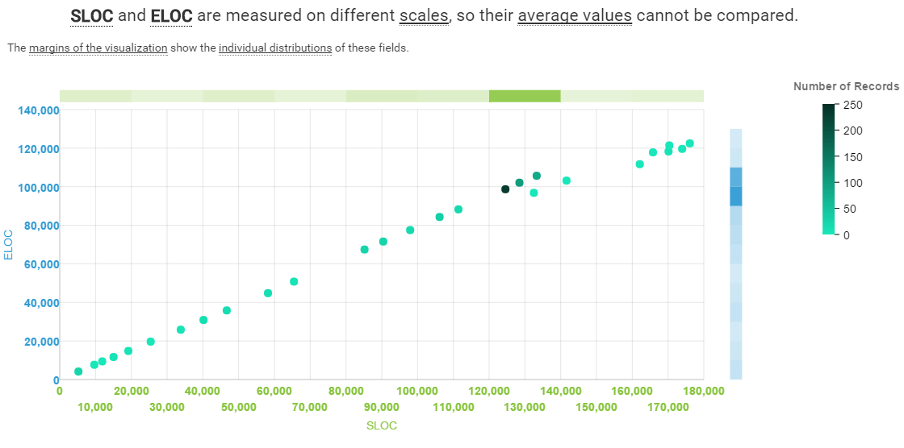

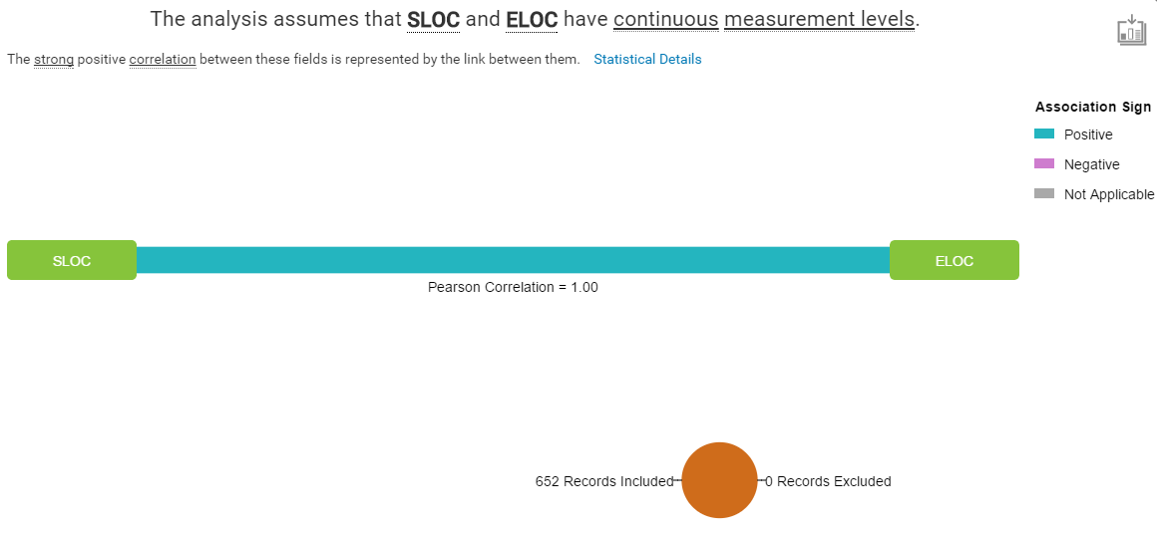

Looking at the Pearson Correlation which is 1, it indicate that there is a strong positive correlation between them. We can conclude that when there is more source lines of code, there is more effective lines of code.

2) How effective is the communication between users and developers?

COM_USR_SUBJ_3M----the number of different subjects

(eg. A question and its response) that have

been posted on the mailing list in the last 3

months

COM_USR_RESP_VOL_3M ----the total number of replies to requests

on the user mailing list in the last 3

months

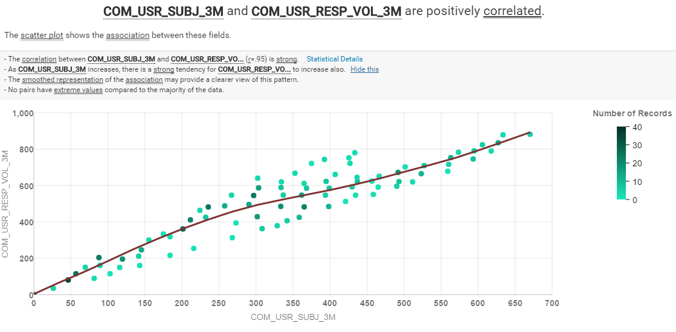

From the regression graph we can see that the number of different subjects that have been posted on the mailing list in the last 3 months and the total number of replies to requests on the user mailing list in the last 3 months is positively correlated.

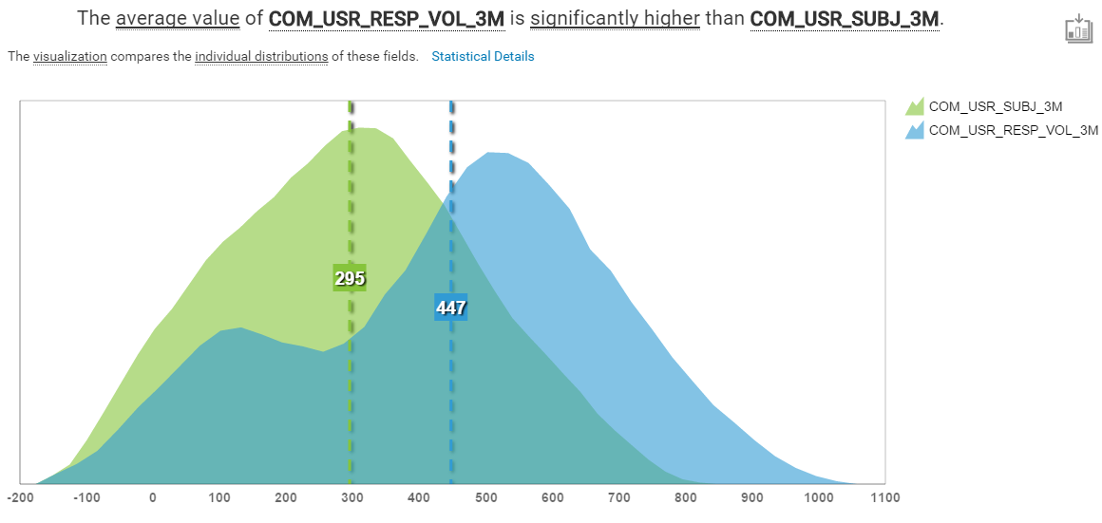

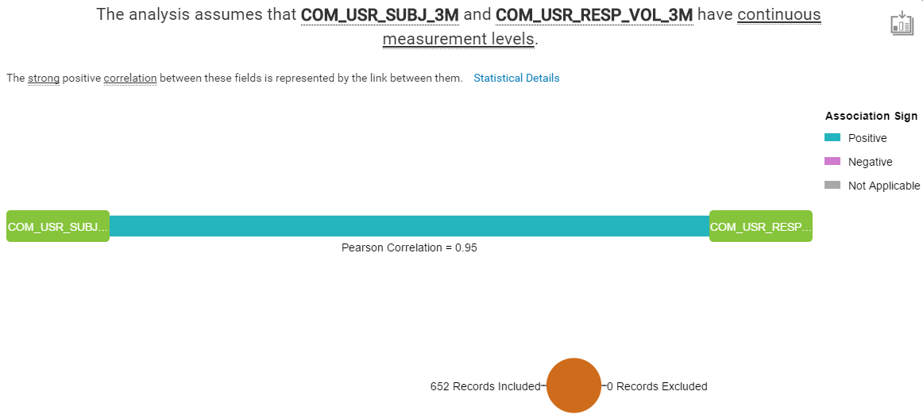

Looking at the Pearson Correlation which is 0.95, it indicate that there is a strong positive correlation between them. We can conclude that when there is more number of different subjects that have been posted on the mailing list, there is more total number of replies to requests on the user mailing list. Which suggest that there is an effective communication between users and developers.

HO: The more the number of developers involved, the more bugs fixed and increase of number of commits.

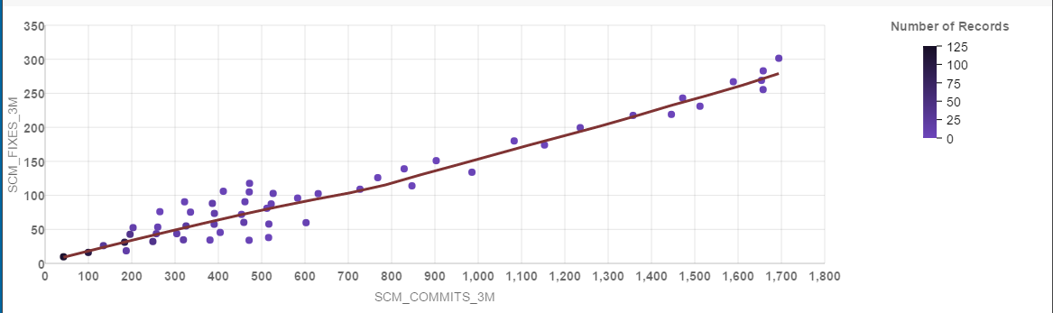SCM_COMMITS_3M and SCM_FIXES_3M are positively correlated

The correlation between SCM_COMMITS_3M and SCM_FIXES_3M (r=0.96) is strong. As SCM_COMMITS_3M increases, there is a strong tendency for SCM_FIXES_3M to increase also.

The analysis assumes that SCM_COMMITS_3M and SCM_FIXES_3M have continuous measurement levels

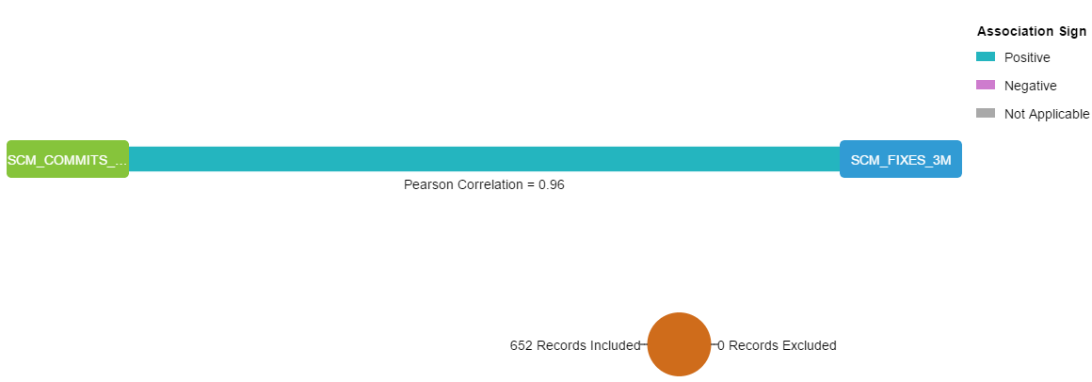

The strong positive correlation between these fields is represented by the link between them.

What influences SCM_FIXES_3M?

SCM_FIXES_3M is a continuous target, so a linear regression (ANOVA) based approached is used.

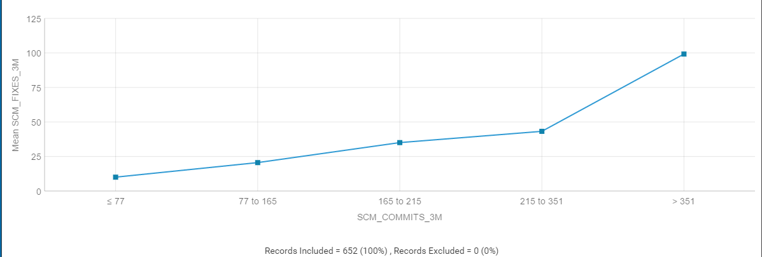There is a significant strong main effect of SCM_COMMITS_3M on SCM_FIXES_3M. Reason being, as the bugs are being fixed, it will then commits to the repository.

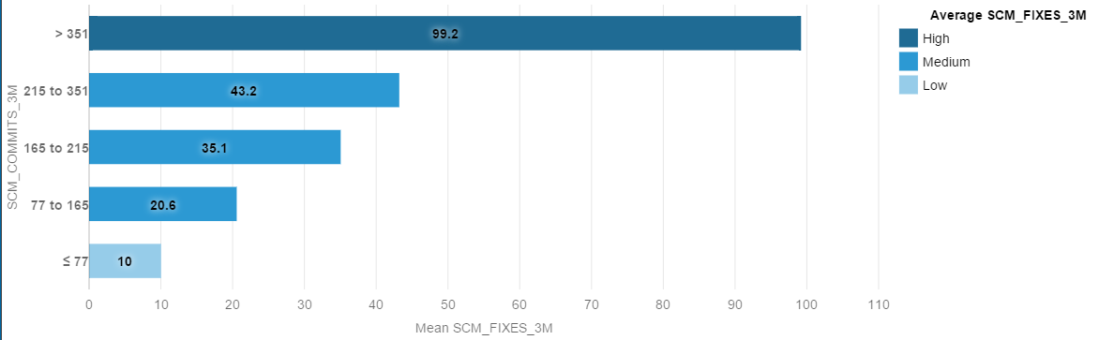SCM_COMMITS_3M drives SCM_FIXES_3M( Predictive strength: 53%)

Each bar represents the SCM_FIXES_3M average at a level of SCM_COMMITS_3M.

Levels with high or low SCM_FIXES_3M averages have more influences.

Grouping the levels into high, medium, or low averages may reveal additional insights about the impact of SCM_COMMITS_3M on SCM_FIXES_3M.

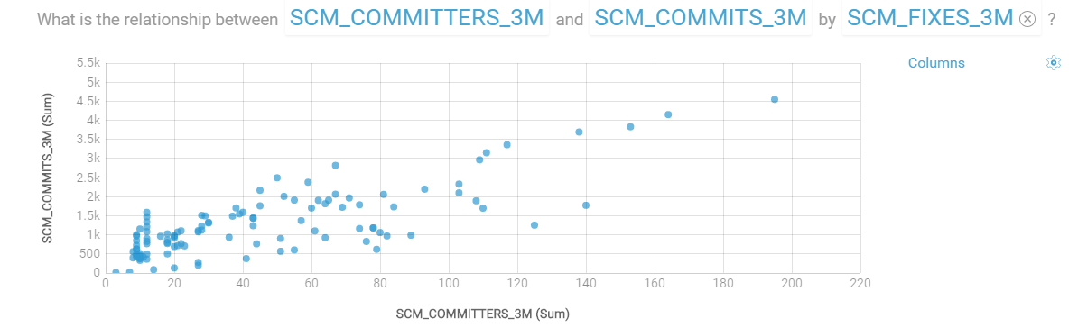This line graph shows that the relationship between committers and commits is rather linear proving that with more contributions from committers, more commits are happening.